GLAB 330.2.2 - Standard Deviation

Introduction:

Standard Deviation (σ) in statistics, typically denoted by σ, is a measure of how much a data set varies (dispersion) between values in a set of data. The lower the standard deviation, the closer the data points tend to be to the mean (or expected value), μ. In this lab, we will demonstrate how to calculate the standard deviation.

Learning Objective:

By the end of this lab learners will be able to calculate the standard deviation.

Given Dataset

Imagine that we have the following data set representing the number of books read by five learners in a month:
Number of Books (X)
2
4
4
4
5
5
7
9

Instructions:

Here are the steps to calculate the standard deviation:

- Calculate the mean (average) of the data set:
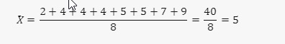
- Calculate the squared differences from the mean for each data point:
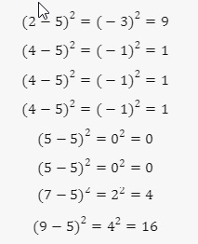
- Calculate the average of these squared differences (variance):
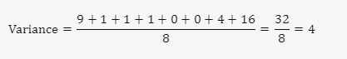
- Take the square root of the variance to get the standard deviation:

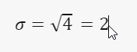
The standard deviation of the number of books read by these students is 2. This means that on average, the number of books read by each student deviates from the mean by 2 books.

Canvas Submission Instructions:
- Upload your project to your GitHub account without setting it to private.
- Utilize the `README` file for any necessary additional instructions.
- Incorporate suitable comments throughout your project.
- Share the GitHub link on Canvas by clicking on the "Start Assignment" button located in the top-right corner of the Assignment page.

